*Absorbance/Fluorescence Spectrophotometer*

Li Xingqi (Author)

Raffles Girls’ School (Secondary)

Singapore

[xingqi.li02@rafflesgirlssch.edu.sg](mailto:xingqi.li02@rafflesgirlssch.edu.sg)

Tan Wan Lin (Author)

Raffles Girls’ School (Secondary)

Singapore

[wanlin.tan02@rafflesgirlssch.edu.sg](mailto:wanlin.tan02@rafflesgirlssch.edu.sg)

Kwa Minyi Samantha (Author)

Raffles Girls’ School (Secondary)

Singapore

[samantha.kwa02@rafflesgirlssch.edu.sg](mailto:samantha.kwa02@rafflesgirlssch.edu.sg)

*Abstract***—** Absorbance spectrophotometers are instruments that measure the ratio of the incident light transmitted through a solution. They are employed as tools for chemical analysis, to determine the concentrations of substances in the analyte. They measure the amount of light that passes through a sample material, and by comparison to the initial intensity of light, subsequently measure the amount of light absorbed by the sample. The concentration of the analyte is inversely proportional with the intensity of light transmitted for absorbance spectrophotometry. Fluorescence spectrophotometers are instruments that are primarily used in the biochemistry and biophysics sectors of research. In fluorescence spectrophotometry, an emission spectrum, which refers to the light emitted by the analyte can be measured. The concentration of the analyte is directly proportional with the intensity of the emission for fluorescence spectrophotometry. In this project, we have not only built a functional spectrophotometer that combines both absorbance and fluorescence spectrophotometry, but made it affordable, accessible and easy-to-use for the wider audience.

# Introduction

Our primary research question focuses on creating a spectrophotometer that combines absorbance and fluorescence spectroscopy. With a spectrophotometer, a number of analyses can be carried out. However, newly manufactured research grade **spectrophotometers are often costly**. Through this project, we aim to create a compact, affordable and user-friendly spectrophotometer that combines both absorbance and fluorescence modes.

# Materials and Methods

## Design Methodology

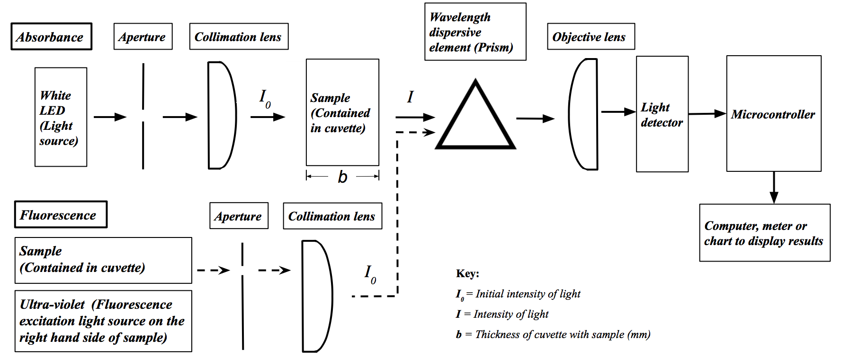

Figure 1. Block diagram of our absorbance and fluorescence spectrophotometer

The main components of our spectrophotometer are light sources, lenses, samples contained in a containing elements, a wavelength dispersive element, a light detector, and a computer, meter or chart to display results (Fig 1).

The lenses used are 25.0 mm diameter x 50.0 mm focal length, commercial grade, plano-convex lenses (Edmund Optics stock #27-251). As the collimation and objective lenses have to collect and focus light (Fig 1.2), towards the prism and the detector respectively, we required a converging lens with a positive focal length. The focal length of the objective lens was chosen so that the spectrum spans the entire width of the detector; for simplicity, the same lens type was used for collimation. The glass type is borosilicate Schott BK-7 glass. Due to its high Abbe number[1] of 64.20 (refer to Diagram 1 in the appendix) and thus low dispersion, chromatic aberration is minimised.

The wavelength dispersive element in our prototype is a 25.0 mm commercial grade equilateral prism (Edmund Optics stock #27-688). Unlike gratings which generate spectra in multiple diffraction orders, a prism eliminates the chances of multiple overlapping spectra. We chose glass type NSF-11 with a low Abbe number of 25.80 (refer to Diagram 1 in the appendix), which means a greater dispersion over the visible spectrum.

For the detector, a TSL1402R 256 x 1 linear sensor array of 256 photodiodes was used. A programme was needed to activate the sensor, convert conditioned sensor signals to digital values, display the data obtained in graphical form to show the spectrum on a monitor, allowing us to analyse the results. The programme commanding the light sensor is written in C++, the commands are then transferred to an Arduino Uno REV3, which is connected to the sensor. The interface in which users operate the prototype is written in Python.

Data including the focal length and the position of the components were entered in a Python code to produce a simulation (Fig 2) showing the path of light rays through the lenses and prism. This was to determine the optimal position of the light source, prism and detector. Based on that, we designed our prototype which combines both absorbance and fluorescence spectrophotometry (Fig 3; Diagram 2 in the appendix contains the layout with dimensions).

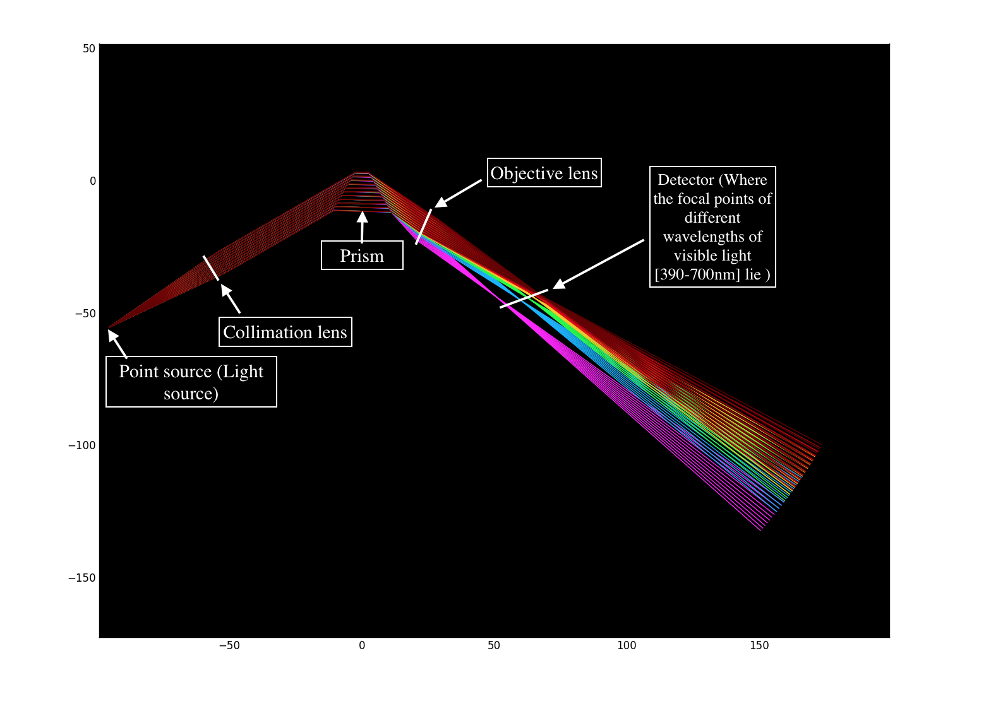

Figure 2. Python simulation of light rays through different components

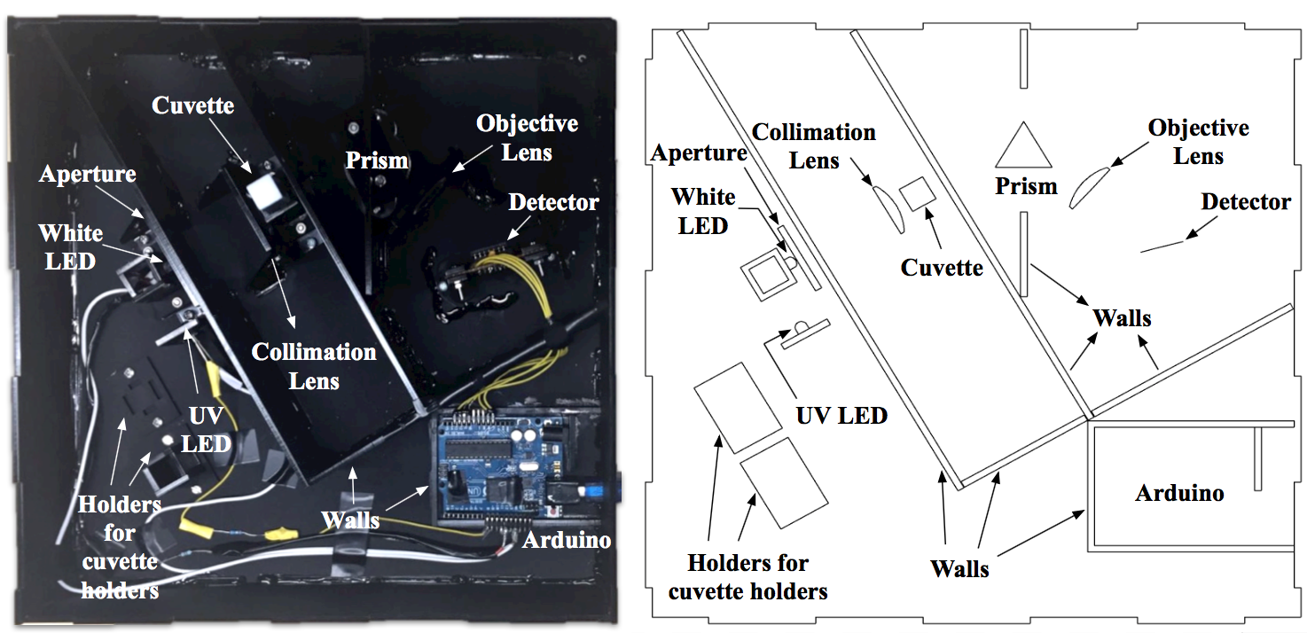

Fig 3. Top view of our prototype (Left) & General design of our prototype (Right)

## Experiment Methodology

For calibration of the wavelength axis, a compact fluorescent light bulb was used as the light source as it has multiple characteristic and well-known emission peaks, allowing for an easy comparison of calibration graph obtained from our results (Fig 4 ).

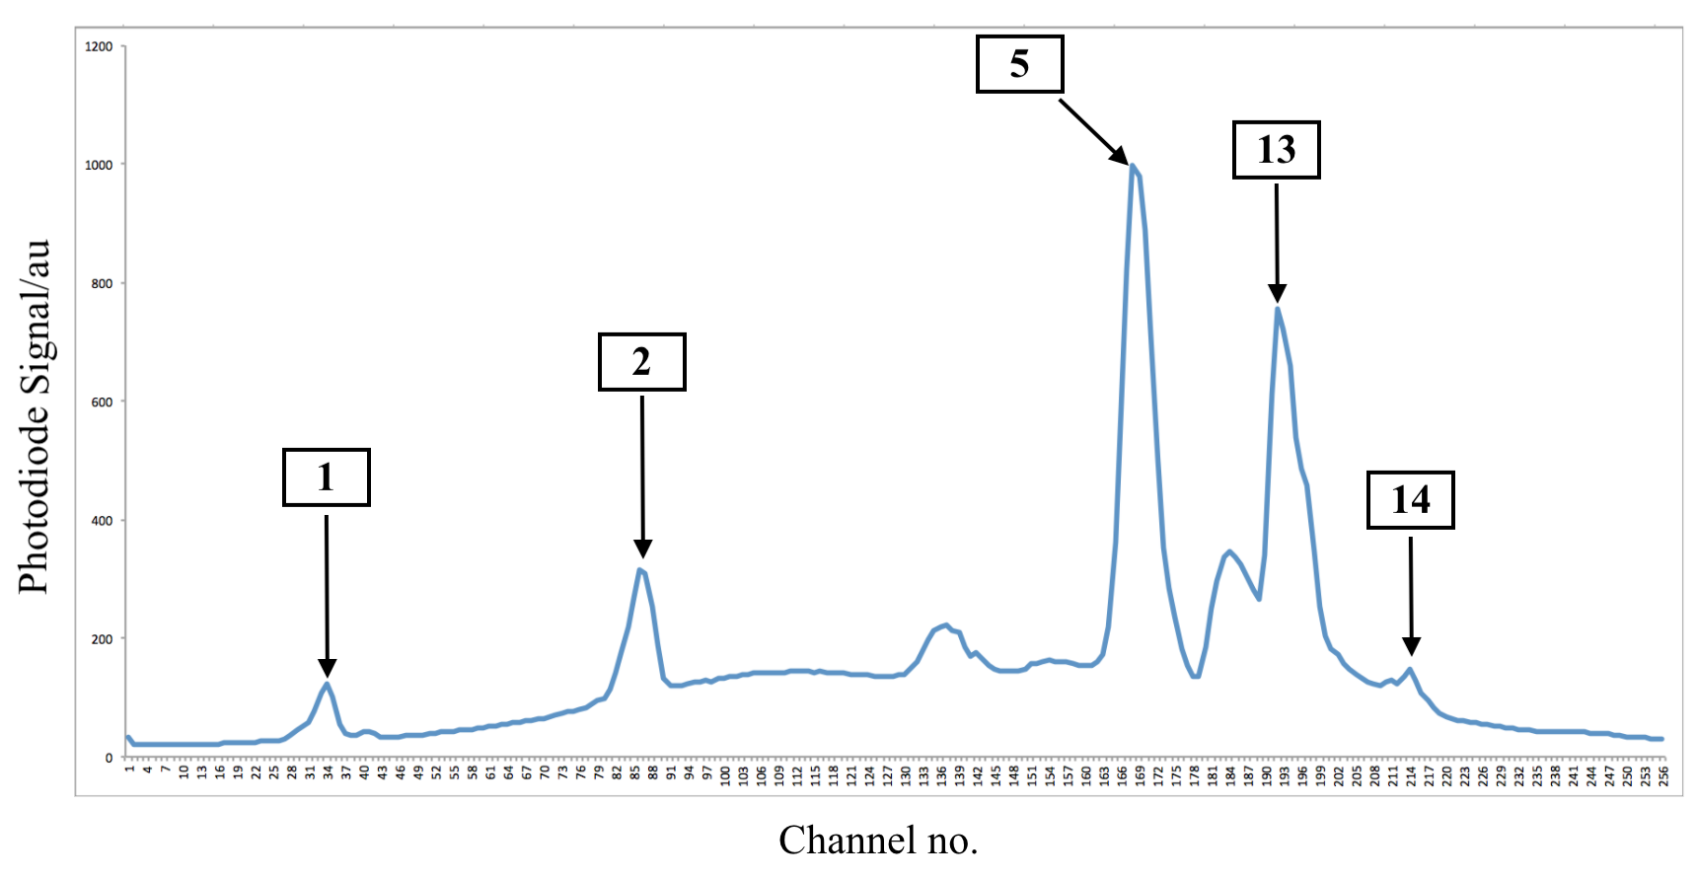

Figure 4. Calibration graph of fluorescent lighting spectrum obtained from prototype

We then used the corresponding numbered wavelengths and pixel numbers to obtain a function that was used to calibrate our prototype, reducing percentage and systematic errors in the readings. A best-fit smooth curve in the form of a third-degree polynomial was plotted and the parameters (Table 1 in Appendix) obtained determined our x-axis in the graphs displaying the result, which is wavelength in nanometers.

A white light emitting diode (LED) was chosen as the light source for absorption measurements. In comparison to cool-white fluorescent light, which has a very “spiky” spectrum (Fig 5), the spectrum of a white LED is more even (Fig 6). Moreover, in comparison to incandescent light, white LED emits less heat, preventing the acrylic set up from possibly melting.

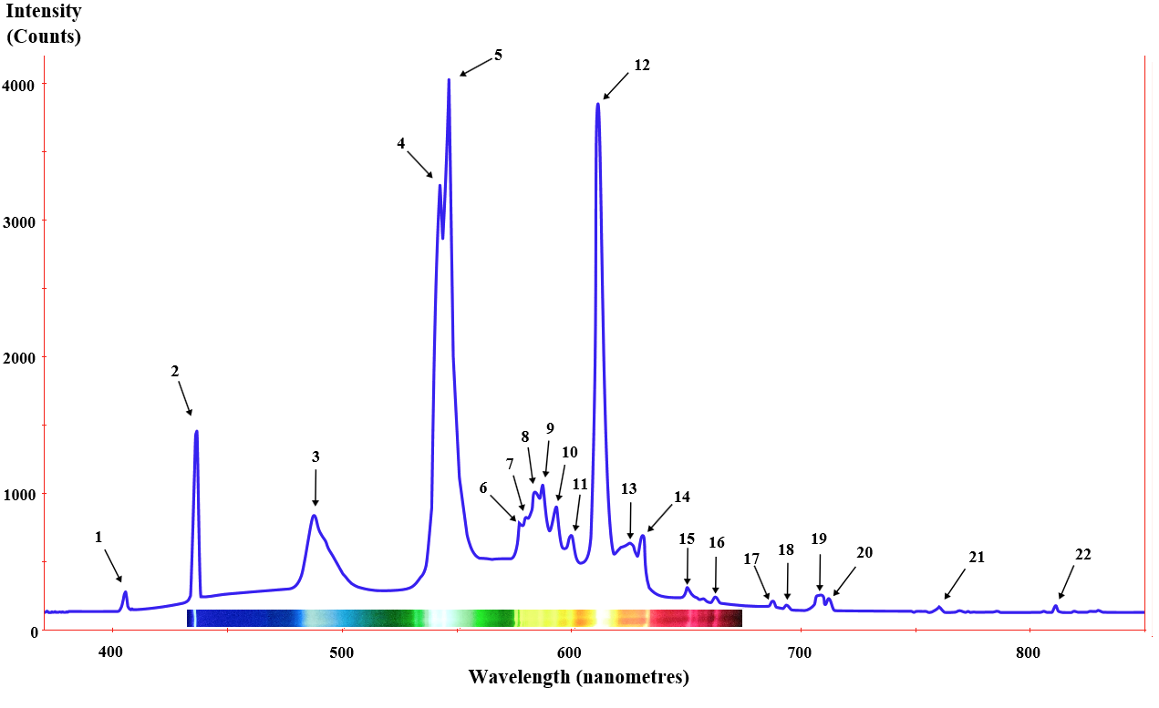

Figure 5. Cool-white fluorescent light spectrum with numbered emission peaks. [2]

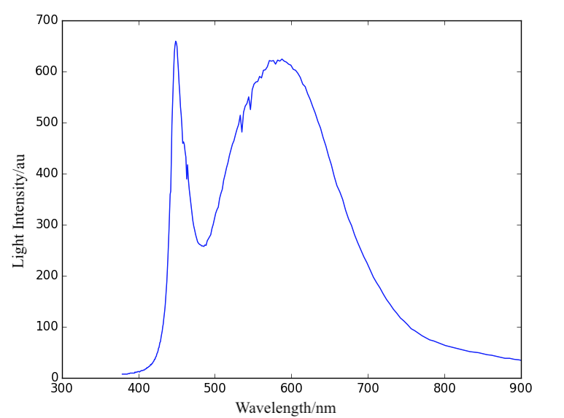

Figure 6. Spectrum of a high-powered white LED

For fluorescence spectrophotometry, an ultraviolet (UV) LED was chosen as the light source to excite the fluorescent material in the sample, in this case quinine, to emit a bluish-green emission (Photo 1 in Appendix).

After calibrating the prototype, the following substances were tested for absorbance: **3 ml of distilled water** as control (Graph 1 and Graph 2); a series of **5 ml Cyan and Magenta printer ink solutions** (Daiso) in which each consecutive Cyan and Magenta ink solution is further diluted by a factor of 2. These inks were chosen based on their accessibility. The dilution of Cyan and Magenta solutions starts from a 100% concentration, referring to our stock solution, which is made up of 0.5 ml ink and 95.5 ml water (Graph 1). For fluorescence spectrophotometry, **Schweppes tonic water** with a quinine concentration of **67.9 mg/L** [11] was tested, diluted by a factor of 2 for every successful concentration. For an example of the experiment setup, refer to Photo 2 in the appendix.

The rationale behind the experiment was to test if our prototype is sensitive to differences in concentration of solutions, a principal factor in the working accuracy of a spectrophotometer.

# Results and Discussion

## Absorbance spectrophotometry

Our hypothesis for this experiment involving absorbance spectrophotometry is: As the concentration of printer ink decreases, the more light the solution allows to pass through.

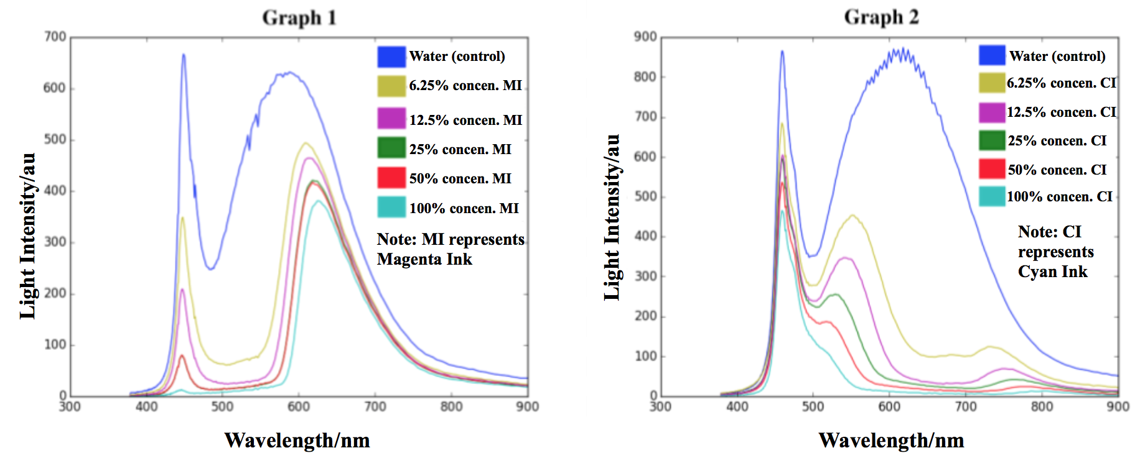

Graph1. Raw spectra of Magenta ink Graph 2. Raw spectra of Cyan ink

As can be seen from both Graph 1 and 2, as the concentration of ink decreases, the more light can be detected. This is in agreement with our hypothesis. Also observed from Graphs 1 and 2 is that as the solutions are diluted by a factor of 2, the differences will be magnified by 2 proportionately.

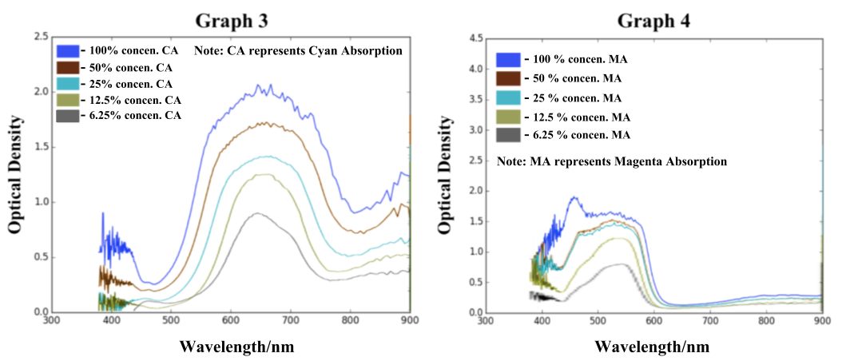

Graph 3. Absorption ratios of Cyan ink

Graph 4. Absorption ratios of Magenta ink

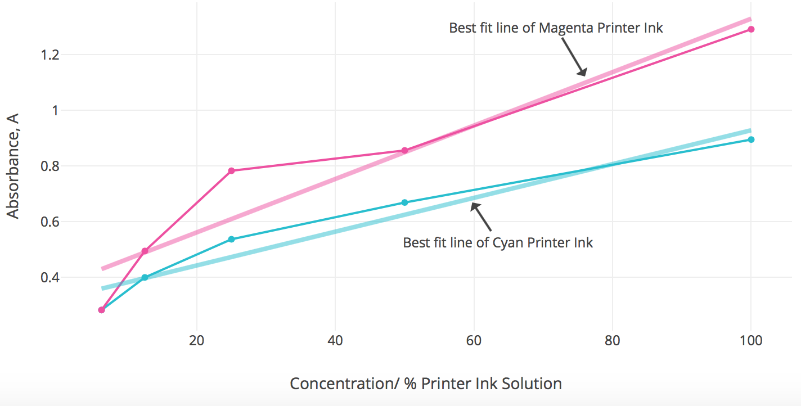

Graph 5. Graph of Absorbance against Concentration of Magenta and Cyan Printer Ink Solutions

It is also observed that the Cyan ink allows blue and green light to pass through and the Magenta ink allows red and blue light to pass through, which means that our spectrophotometer is able to differentiate the different wavelengths of light. In summary, our prototype is able to carry out absorbance spectrophotometry.

The Lambert-Beer Law [1] is the linear relationship between absorbance and concentration of an absorbing species, and the concentration of a solution is directly proportional to the amount of light absorbed [1]. Referring to Graph 5, the Beer-Lambert law is in agreement with the results obtained from our spectrophotometer.

## Fluorescence spectrophotometry

Our hypothesis for this experiment involving fluorescence spectrophotometry is: As the concentration of quinine in tonic water decreases, the lower the fluorescence intensity.

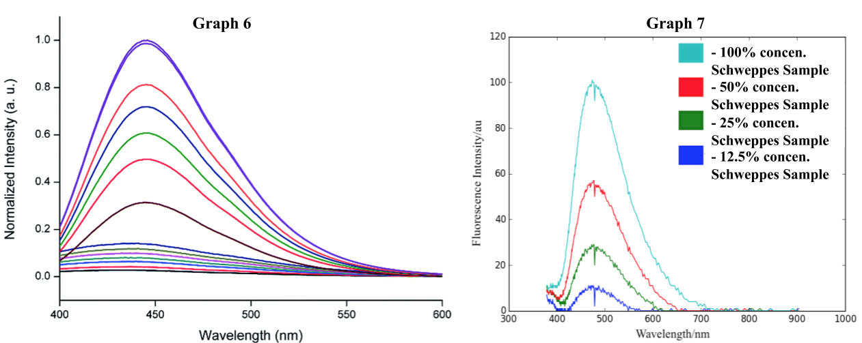

Graph 6. Reference Emission Spectra of Quinine Sulfate (J. Mater. Chem. A, 2015,3) [12]

Graph 7. Emission spectra for different concentrations of Schweppes tonic water

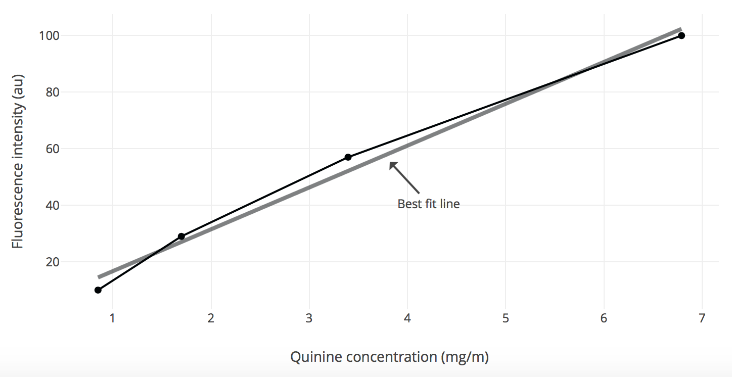

Graph 8: Graph of Fluorescence intensity against Quinine concentration

Similar to Graphs 1 and 2, Graph 7, which is obtained from our prototype, shows that the difference between each graph doubles. As shown in Graph 8, the fluorescence intensity increases as the concentration of quinine in the Schweppes tonic water sample increases. This is aligned with our hypothesis. The wavelength of the emission spectrum is between 400 to 500 nm, within the blue to green range which is characteristic of the glow that quinine emits.

## Limitations

However, there are some limitations to our current spectrophotometer. Firstly, optical density can only be measured up to O.D. 3 (log 1000) due to the 10-bit (1024 step) resolution of the analog input of the Arduino microcontroller. This can be circumvented by carefully calibrating exposure times such that the dynamic range is expanded. For example, taking a 0.1 second exposure for reference while taking a 1 second exposure for the sample would allow you to collect 10 times more light. Secondly, our sensor is made from two 128-channel chips, hence there is a discontinuity between the 128th and 129th photodiode that causes a “spike” at the corresponding data point. Lastly, there is limited sensitivity at some wavelengths in absorption mode due to the lack of wavelengths in the LED source. These gaps in wavelength could be filled in with coloured LEDs of the corresponding wavelengths.

##### IV. Conclusion

To summarise, we designed and built a prototype spectrophotometer which combines both absorbance and fluorescence spectrophotometry, after which we experimented with to test its performance and ensure its reliability by taking relevant spectra. Our results are in agreement with the Lambert-Beer law, demonstrating that the prototype is capable of quantitative spectroscopic experiments.

In conclusion, we successfully built a spectrophotometer from easily available and inexpensive components that is capable of absorption and fluorescence emission measurements. Wavelength calibration is easily performed using widely available household compact fluorescent lightbulbs, and the absorption spectra are quantitative, allowing, for example, the concentration measurements of unknown samples.

##### Acknowledgment

We would like to acknowledge and thank Science Centre Singapore for letting us use their facilities, and our mentor Dr Wulf Hofbauer for his guidance; as well as Raffles Girls’ School (Secondary) for giving us the opportunity to take part in this research.

##### References

1. Beer-Lambert law. (2017, August 1). Segen's Medical Dictionary (2011). Retrieved from <http://medical-dictionary.thefreedictionary.com/Beer-Lambert+law>
2. Fluorescent lamp. (2017, July 26). Retrieved from <https://en.wikipedia.org/wiki/Fluorescent_lamp>
3. Optical Glass | Edmund Optics. (2017, July 28). Retrieved from <https://www.edmundoptics.com/resources/application-notes/optics/optical-glass/>
4. Using the Spectrophotometer - ResearchGate. (2017, August 3). Retrieved from <https://www.google.com.sg/url?sa=t&rct=j&q=&esrc=s&source=web&cd=7&ved=0ahUKEwj__avSqLzVAhXEKY8KHc6MBoQQFgg_MAY&url=https%3A%2F%2Fwww.researchgate.net%2Ffile.PostFileLoader.html%3Fid%3D56b0789160614b7ffe8b4567%26assetKey%3DAS%253A324615514066946%25401454405777976&usg=AFQjCNF5tVr4CWAtzFgTRfiiPw3y-v24-w>
5. Understanding Optical Lens Geometries | Edmund Optics. (2017, August 6). Retrieved from <https://www.edmundoptics.com/resources/application-notes/optics/understanding-optical-lens-geometries/>
6. Spherical aberration in lenses | The Ground Up. (2017, August 10). Retrieved from <https://amazing-space.stsci.edu/resources/explorations/groundup/lesson/glossary/term-full.php?t=spherical_aberration_in_lenses>
7. Understanding Chromatic & Spherical Aberration of Lenses | Digital Photography Life. (2017, August 10). Retrieved from <http://digitalphotographylive.com/chromatic-spherical-aberration/>
8. TSL1402R 256 × 1 Linear Sensor Array with Hold | Mouser Electronics. (2017, August 6). Retrieved from <http://www.mouser.com/ds/2/588/TSL1402R_DS000147_2-00-559278.pdf>
9. Spectrophotometers. (2017, August 10). Retrieved from <https://www.medexsupply.com/search.php?q=spectrophotometers>
10. Overfitting. (2017, August 10). Retrieved from <https://en.wikipedia.org/wiki/Overfitting>
11. Ohira, A., Yamaguchi, S., Miyagi, T., Yamamoto, Y., Yamada, S., Shiohira, H., . . . Takahashi, K. (2013, August). Fixed eruption due to quinine in tonic water: a case report with high-performance liquid chromatography and ultraviolet A analyses. Retrieved January 03, 2018, from <https://www.ncbi.nlm.nih.gov/pubmed/23724855>
12. Miao, P., Tang, Y., Han, K., & Wang, B. (2015, June 15). Facile synthesis of carbon nanodots from ethanol and their application in ferric(III) ion assay. Retrieved January 05, 2018, from <http://pubs.rsc.org/en/content/articlelanding/2015/ta/c5ta03278d/unauth#!divAbstract>

##### Appendix

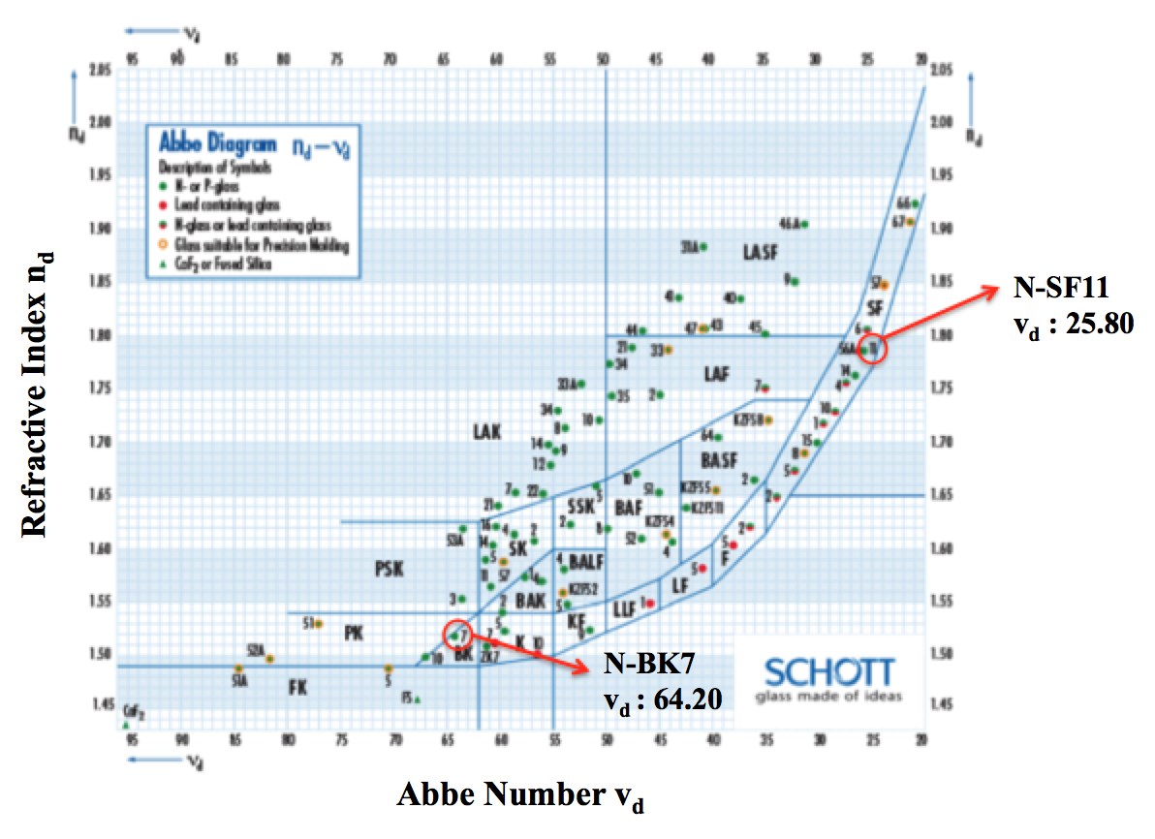

Diagram 1: Annotated Schott Abbe Diagram [3] (Source: Edmund Optics)

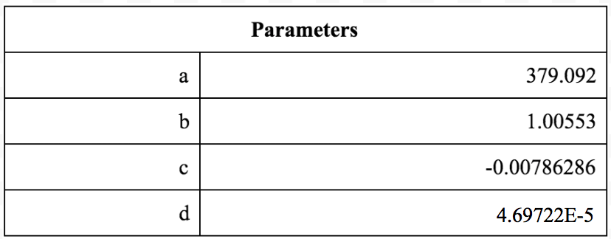

Table 1: Parameters of third degree polynomial for translation of the photodiode channel to the wavelength in nanometers

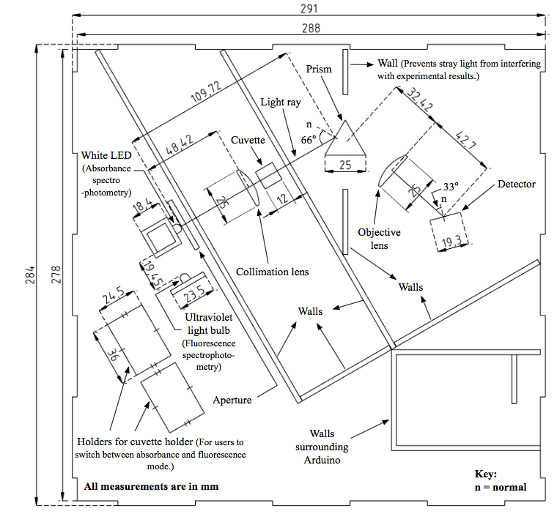

Diagram 2: scaled layout of our spectrophotometer

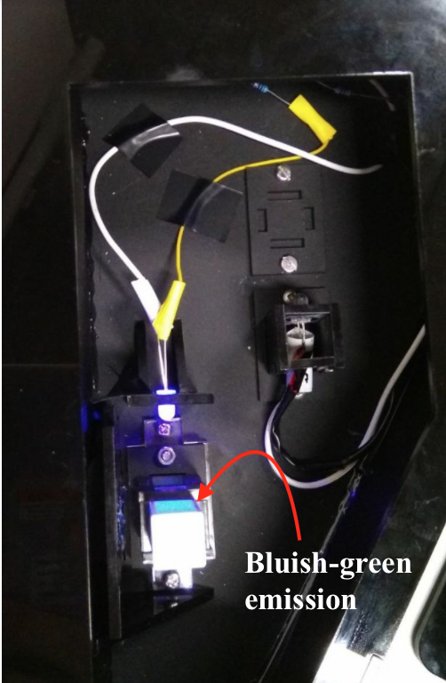

Photo 1: Emission from sample with quinine, a common fluorescent marker

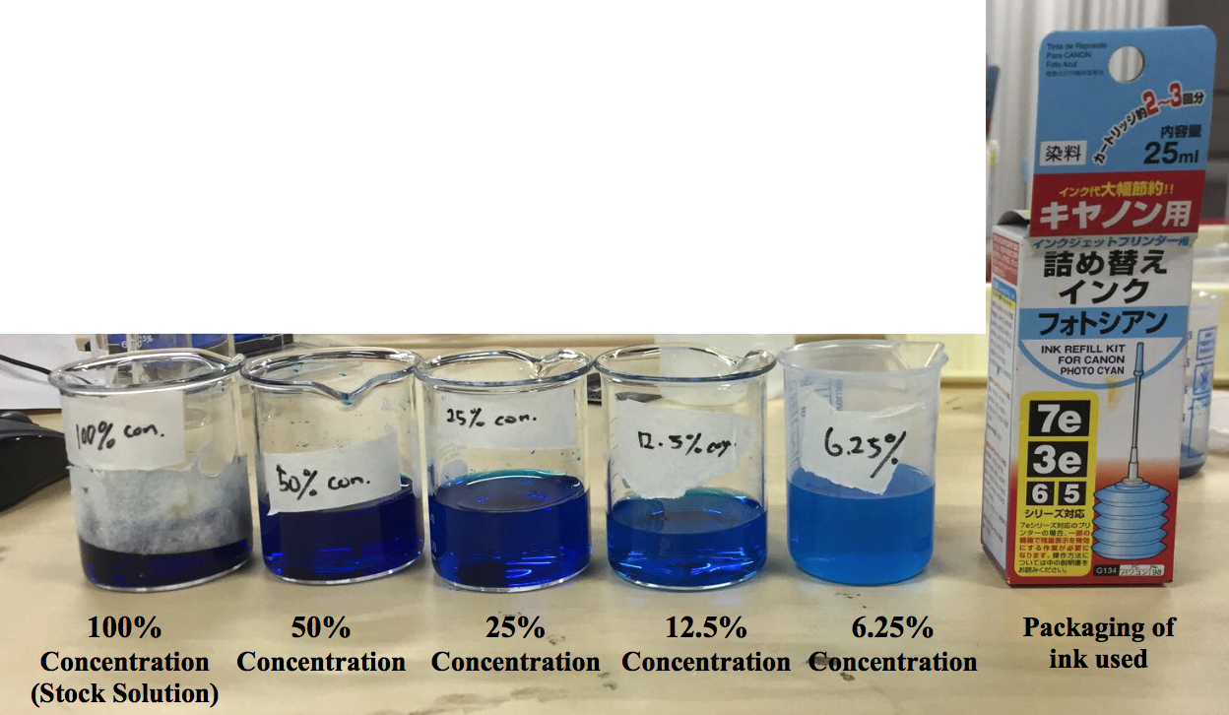

Photo 2: Experiment setup of various concentrations of Cyan Ink solutions

1. Abbe Number is the measure of a material’s dispersion (variation of refractive index versus wavelength), with higher Abbe numbers representing lower dispersion.